**HOMEWORK**

**Equivalence partitioning**

**Q. 101: The Switch is switched off once the temperature falls below 18 and then it is turned on when the temperature is more than 21. When the temperature is more than 21. Identify the Equivalance values which belong to the same class.**

A. 12,16,22  
B. 24,27,17  
**C. 22,23,24**D. 14,15,19

**Q. 111: One of the fields on a form contains a text box which accepts alpha numeric values. Identify the Valid Equivalence class**

A. BOOK  
B. Book  
**C. Boo01k**  
D. book

**Q. 261: One of the fields on a form contains a text box, which accepts alphabets in lower or upper case. Identify the invalid Equivalence class value.**

A. CLASS  
B. cLASS  
C. CLass  
**D. CLa01ss**

**Q. 523: In a system designed to work out the tax to be paid:**

**An employee has $4000 of salary tax free.  
The next $1500 is taxed at 10%.  
The next $28000 after that is taxed at 22%.  
Any further amount is taxed at 40%.**

**To the nearest whole pound, which of these groups of numbers fall into three DIFFERENT equivalence classes?**

A. $4000; $5000; $5500.  
B. $32001; $34000; $36500.  
C. $28000; $28001; $32001.  
**D. $4000; $4200; $5600.**

**Q. 579: In an Examination a candidate has to score minimum of 24 marks in order to clear the exam. The maximum that he can score is 40 marks. Identify the Valid Equivalence values if the student clears the exam.**

a) 22,23,26  
b) 21,39,40  
**c) 29,30,31**  
d) 0,15,22

**Q. 727: If the temperature falls below 18 degrees, the heating is switched on. When the temperature reaches 21 degrees, the heating is switched**off. What is the minimum set of test input values to cover all valid equivalence partitions?

**A. 15, 19 and 25 degrees**  
B. 17, 18, 20 and 21 degrees  
C. 18, 20 and 22 degrees  
D. 16 and 26 degrees

**Boundary Values Analysis**

**Q. 480: In a system designed to work out the tax to be paid:**

**An employee has $4000 of salary tax free. The next $1500 is taxed at 10% The next $28000 is taxed at 22%**

**Any further amount is taxed at 40%**

**To the nearest whole pound, which of these is a valid Boundary Value Analysis test case?**

A. $1500  
B. $32001  
**C. $33501**  
D. $28000

**Q. 734: Assume postal rates for ‘light letters’ are:**

**$0.25 up to 10 grams;**  
**$0.35 up to 50 grams;**  
**$0.45 up to 75 grams;**  
**$0.55 up to 100 grams.**

**Which test inputs (in grams) would be selected using boundary value analysis?**

A. 0, 9,19, 49, 50, 74, 75, 99,100  
B. 10, 50, 75,100, 250, 1000  
**C. 0, 1,10,11, 50, 51, 75, 76,100,101**  
D. 25, 26, 35, 36, 45, 46, 55, 56

**Q. 860: Arrive-and-Go airline wants to clarify its baggage handling policy, whilst maximizing revenues, and will introduce the following tariffs for all baggage per individual customer (weights are rounded up to the nearest 0.1Kg):**

**The first 2Kg will be carried free of charge.**

**The next 10 Kg will be carried for a flat charge of $10.**

**An additional 15Kg will be charged a total charge of $17.**

**Luggage over this amount will be charged at $5 per Kg, up to a maximum of 150Kg per person.**

**No passenger may take more that 150Kg with them.**

**Which of the following would constitute boundary values for baggage weights in the price calculation?**

A. 0, 5.0, 10.0, 17.0

B. 2.0, 9.9, 15.0, 26.9

C. 1.9, 12.0, 14.9, 150.0

**D. 2.0, 12.1, 27.0, 150.1**

**Q. 863: To  test  an  input  field that  accepts a  two – digit  day  based on a  particular  month  which data  set  demonstrates  boundary  value  analysis?**

A. 0, 1, 16, 31 and 100  
**B. 1, 27, 28, 30 and 31**C. 2, 26, 27, 29 and 30  
D. -1, 0, 15, 32 and 99

**Decision Table**

**Q. 282: What is the expected result for each of the following test cases?**

|  |  |  |  |  |
| --- | --- | --- | --- | --- |
|  | **Rule1** | **Rule2** | **Rule3** | **Rule4** |
| **Conditions** |  |  |  |  |
| Citibank Card  Member | Yes | Yes | No | No |
| Type of Room | Silver | Platinum | Silver | Platinum |
| **Actions** |  |  |  |  |
| Offer upgrade  To Gold Luxury | Yes | No | No | No |
| Offer upgrade to Silver | N/A | Yes | N/A | No |

A. Citibank card member, holding a Silver room  
B. Non Citibank-member, holding a Platinum room  
  
A. A – Don’t offer any upgrade, B – Don’t offer any upgrade.  
B. A – Don’t offer any upgrade, B - Offer upgrade to Gold.  
C. A - Offer upgrade to Silver, B - Offer upgrade to Silver.  
**D. A - Offer upgrade to Gold, B – Don’t offer any upgrade.**

**Q. 820: Given the following decision table:**

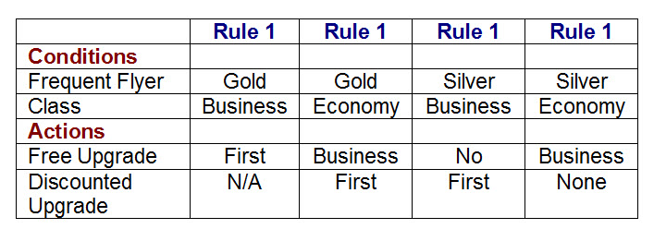

**What is the expected result for each of the following test cases?**

**P. Gold frequent flyer, travelling in Economy class.**

**Q. Silver frequent flyer, travelling in Business class.**

**A. P. Offer free upgrade to Business and discounted upgrade to First. Q. Offer discounted upgrade to First**

B. P. Offer free upgrade to Business but cannot upgrade to First. Q. Offer discounted upgrade to First

C. P. Offer free upgrade to First. Q. Cannot upgrade to First

D. P. Offer discounted upgrade to First. Q. Offer free upgrade to First

**Q.928: A Car-Rental company gives cars in rent to people over 23 years old with clean Driving Record.**

**If customer takes car for Business, then Premium Charge is considered.**

**Make the decision table.**

|  |  |  |  |  |
| --- | --- | --- | --- | --- |
| **Conditions** | **Rule 1** | **Rule2** | **Rule3** | **Rule4** |
| **Age over 23 years** | **No** | **Yes** | **Yes** | **Yes** |
| **Clean Driving record** | **----** | **Yes** | **Yes** | **No** |
| **Business** | **----** | **Yes** | **No** | **---** |
| **Actions** |  |  |  |  |
| **Rent a car** | **No** | **Yes** | **Yes** | **No** |
| **Premium Charge** | **No** | **Yes** | **No** | **No** |
|  | **TC1** |  | **TC2** |  |

**What is the expected result for the following test cases:**

**TCI: A 26-year-old on business but with violations or accidents on his driving record**

**TC2: A 62-year-old tourist with a clean driving record**

A. TCI: Don’t supply car; TC2: Supply car with premium charge.

B. TCI: Supply car with premium charge; TC2: Supply car with no premium charge.

**C.  TCI: Don’t supply car; TC2: Supply car with no premium charge.**

D. TCI: Supply car with premium charge; TC2: Don’t supply car.

**State-transition testing**

Q. 13: Given the following state transition diagram. Which of the following series of state transitions contains an INVALID transition which may indicate a fault in the system design?

Exhibit:

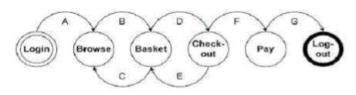

A. Login Browse Basket Checkout Basket Checkout Pay Logout.

B. Login Browse Basket Checkout Pay Logout.

**C. Login Browse Basket Checkout Basket Logout.**

D. Login Browse Basket Browse Basket Checkout Pay Logout.

**Q. 383: Without  testing  all  possible  transitions, which  test  suite  will  test  all  marital  statuses?**

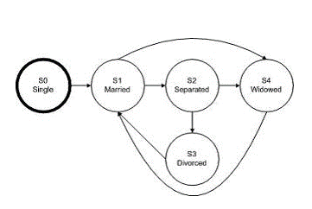

1. SO-S1-S2-S4-S1-S4
2. SO-S1-S2-S3-S1-S2
3. **SO-S1-S4-S1-S2-S3**
4. SO-S1-S2-S3-S4-S1

**Q. 388: Using  the  diagram  below, which  test  suite  will  uncover  invalid  state  transitions  for employee  status  reporting  software?**

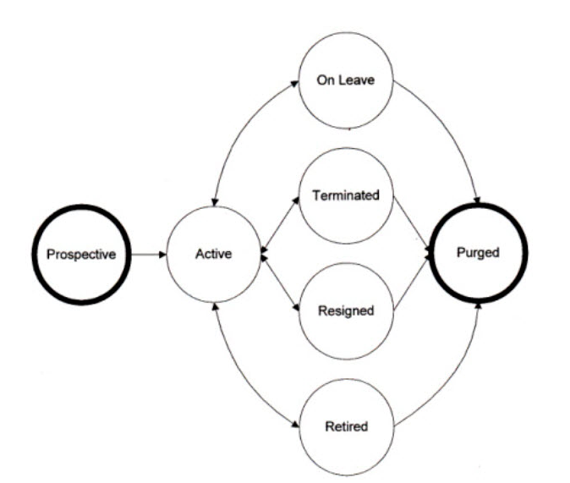

1. Prospective – Active – Resigned – Active – Terminated – Purged
2. **Prospective – Active – On Leave – Active – Resigned – Retired**
3. Prospective – Active – Retired – Active – On Leave – Purged
4. Prospective – Active – On Leave – Active – Retired – Active

**Q. 400: Using  the  diagram  below,  which  test  suite  will  check  for  ALL  valid  state  transitions  using  the  LEAST  effort?**

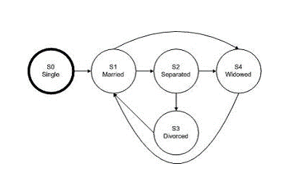

1. **SO-S1-S2-S4-S1-S4-S1-S2-S3-S1**B. SO-S1-S2-S4-S1-S2-S3-S1  
   C. SO-S1-S4-S1-S2-S3-S1  
   D. SO-S1-S2-S4-S1-S4-S1-S2-S3

**Q. 880: Given the following state transition diagram:**

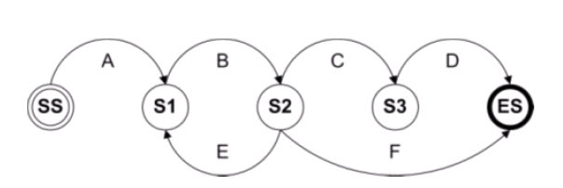

**Which of the test cases below will cover the following series of state transitions?**

**SS – S1 – S2 – S1 – S2 – ES**

**A. A, B, E, B, F**

B. A, B, C, D

C. A, B, E, B, C, D  
D. A, B, F

**№3.** A coffee-machine makes coffee by money.

If you’ll enter enough money – coffee-machine will work, if it’s enough coffee.

If you add enough coffee, machine will work.

Make state-transition diagram.

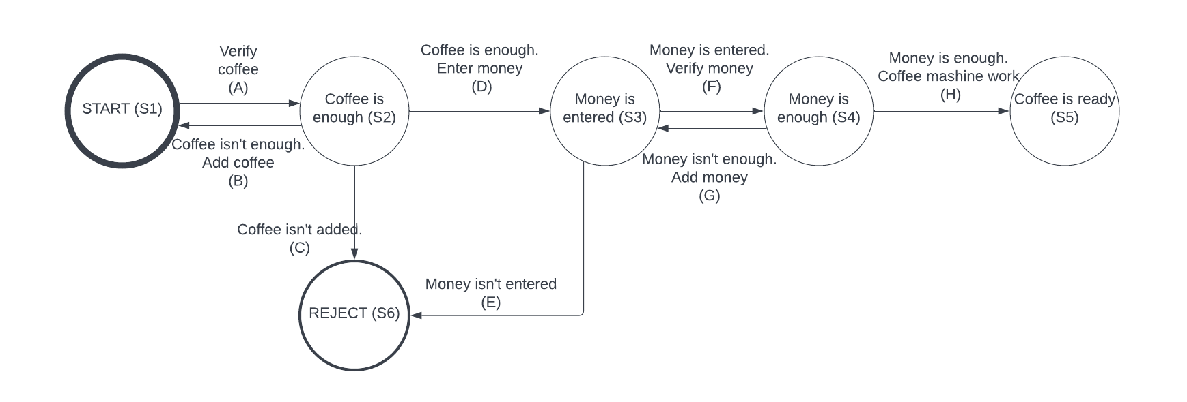

Derive test case(s) to cover all states (use preconditions).

A-B-A-C

A-D-E

A-D-F-G-F-H

**Use case testing**

Take an application or a web-site, make use case diagram and derive at least 3 positive test-cases (**https://dev.azure.com/irinapopovici/QA%20Internship%202022/_testPlans/define?planId=841&suiteId=1294**)

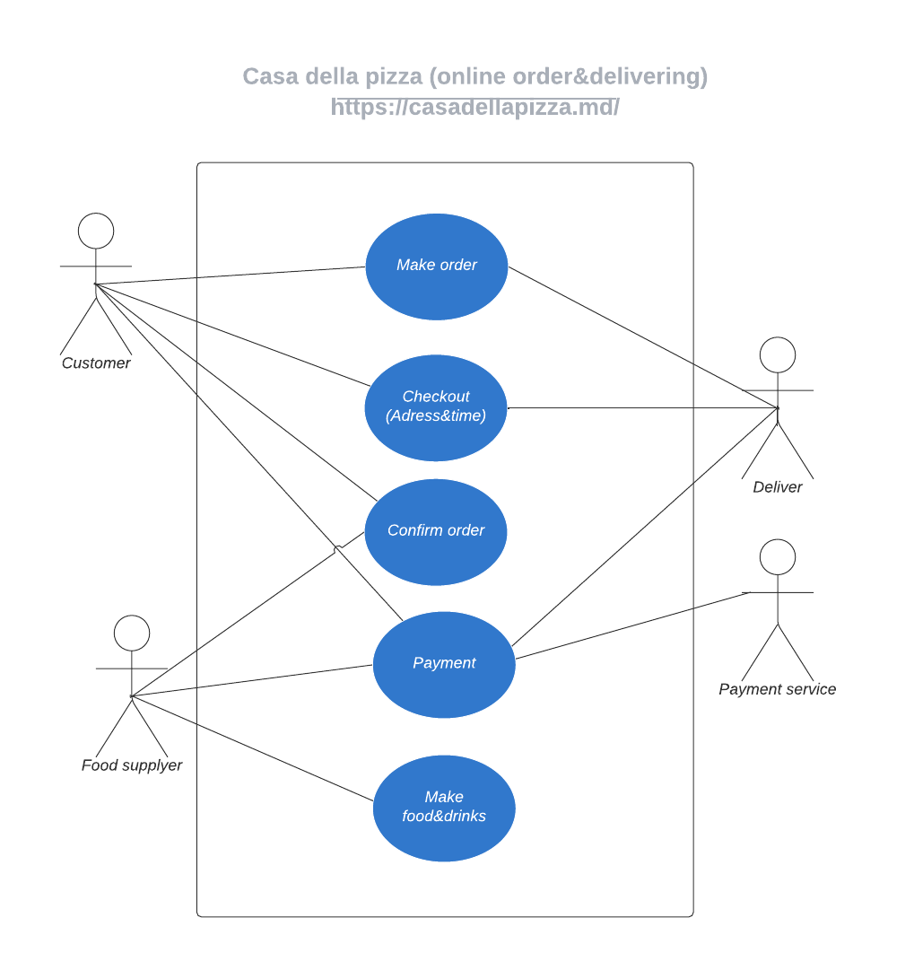

**Pairwise testing (See Pairwise_AllCombinations_HW.xlsx – 2 sheets)**

Using [https://pairwise.teremokgames.com](https://pairwise.teremokgames.com/) tool generate file with all pairs and second file with pairwise testing.

Consider a web shop that should operate with different types of customers:

* individuals
* companies
* partners

their locations:

* European Union
* the USA
* China
* India
* Australia

payment systems:

* VISA
* MasterCard
* PayPal
* bank transfer

different browsers:

* Google Chrome
* Mozilla Firefox
* Safari
* Opera